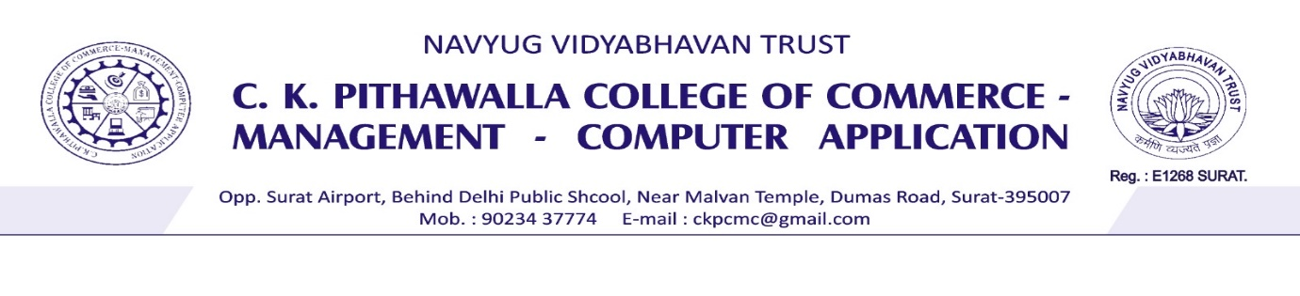

**Certificate**

This is to certify that ***Mr. Vishwakarma Abhishek Ramvriksh (SeatNo:7281), Mr. Singh Abhishek Jitendra (SeatNo:7262), Mr. Dubey Vishal Jaykumar (SeatNo:7185), Mr. Chaudhari Ajit Ashokkumar (SeatNo:7177)*** have successfully completed their Major Project, entitled “***Food Delivery Website (NomNomGo.)*** ” under the guidance of ***Ms. Hetal Mehta*** , as a partial fulfilment of sixth semester requirement for the degree of “***Bachelor of Computer Application (BCA)***” during academic year ***2024-25***.

Date : ___/___/______ _______________________

Signature of Project Guide

_______________________

Signature of External Examiner



**Certificate**

This is to certify that ***Mr. Vishwakarma Abhishek Ramvriksh*** Seat No. ***7281*** has prepared her Seminar, entitled “***Metaverse***” under the guidance of “***Ms. Hetal Mehta***” , as a partial fulfilment of sixth semester requirement for the degree of “***Bachelor of Computer Application (BCA)***” during academic year ***2024-25***.

Date : ___/___/______ ______________________

Signature of Seminar Guide

_________________________

Signature of External Examiner